FUTURE FOUNDATIONS
NEWSLETTER SEPTEMBER 2021

Welcome to our second newsletter.
Since our first newsletter in March 2021, we have managed to sponsor four additional young people to secondary school or college thanks to our raffle success. Future Foundations, as well as most other charities, are finding the current financial times difficult and we are looking forward to fundraising in person and raising awareness about what we are doing – we hope to see you soon.
Best wishes,
Sharon and Joseph Lewa
What We Do
Future Foundations main objectives are to facilitate access to higher and further education for young people aged 12-25 years, from disadvantaged families who are unable to pay for education fees and additional costs, to improve future careers / prospects. To date we have supported 18 young people.
History Joseph grew up in Sabaki, Kenya, and was the first person from his village to go to university. This was due to his uncle sponsoring him to go to secondary school. Joseph had to work at nights, weekends and holidays to get pocket money and also paid some of the school fees as well as to provide for his six younger siblings and mum, as his dad passed away in 2002, when he was 16 years old. In 2010, Vicki & Sam Samuels and Sharon (his now wife) visited Rainbow Community Care Orphanage, where Joseph was working. Vicki & Sam decided to sponsor him to go to Mount Kenya University. In 2012, Joseph graduated with a Diploma in Social Work & Community Development. Joseph now lives in the Isle of Skye with his wife, Sharon, who he met at Rainbow, and their two daughters Anna & Faith. He works as a Programme Assistant at Columba 1400, a project which supports young people from disadvantaged backgrounds and is also now a qualified personal trainer. Sharon is originally from Skye and works as a social worker for NHS Highland.
Joseph knows that without the support and faith of his uncle, Vicki & Sam, that his life (and his siblings’ lives) would be very different. Future Foundations was started in April 2013 to support young people in Joseph’s hometown in Sabaki, Kenya. One of our trustees in Kenya, Samuel Chiro, went to university with Joseph and is now a social worker in Malindi General Hospital. Future Foundations was an idea that Joseph and Chiro developed together after graduating.

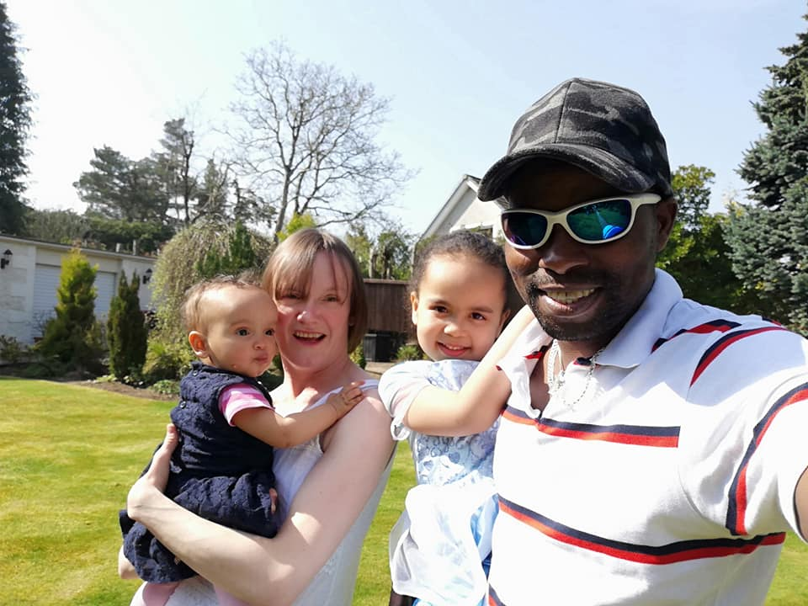
+
Website https://www.futurefoundations.info
www.facebook.com/futurefoundationskenya

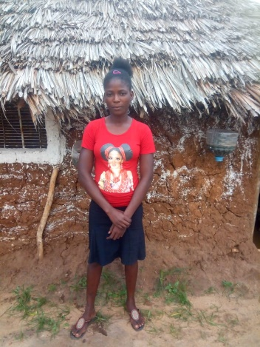
0
RAFFLE SUCCESS
Thank you to everyone who bought a raffle ticket for our online raffle in April – we sold 240 tickets and raised a fantastic £480. Thank you to Skye Shrubs, Isle of Skye Fudge Company, Isle of Skye Candles & Skye Red Fox to name a few, for donating prizes – without such amazing prizes, we wouldn’t of been able to raise the amount we did.
We welcome any suggestion of future fundraising ideas, please get in contact to share your wisdom and initiative!
CONTACT US We are always delighted to receive comments, ideas and any offers of support with all aspects of the charity so place get in touch via Facebook, Instagram or email (new address) contact@futurefoundations.info
Donating Future Foundations entirely depends on fundraising and donations, and every penny goes towards supporting young people into education. We would appreciate it if you would consider making a donation via the methods on our website including Nochex -
https://secure.nochex.com/charity/details.aspx?cN=Future_foundations

Trustee story – Nickson (in his own words)
“I am Nickson Ngumbao (pictured right), from Sabaki, Kenya. I am married and I have two children. I am 35 years old and I was the 7th born in a family of 16 members as my father had 2 wives and had 13 children -only 2 children reached high schools including me being one of them. Currently I work as a teacher in private school called Maboromokoni Junior Academy as well as volunteering for Future Foundation. I started learning at 8yrs old, and went to Kibokoni Primary School until class six however I had to drop out of school because my parents could not pay the school fees. I stayed home for a year, and then I was taken to Sabaki primary school, in 2005 I completed my class eight level. In 2006 I joined Kibokono Secondary School. When I reached Form 2. I dropped out of school again because of school fees. In 2008, I was taken to another school, Barani secondary school in to begin Form 1 again. In 2011, I did my final examination (KCSE). When I finished high school, my father told me enough is enough no more learning, this meant I was to work and help feeding and educating my young brothers and sisters. In 2012, I went at Malindi Eden Roc Hotel to train in store keeping for six months. Then after Eden Roc, I worked as a casual in one site called Mijikenda Residence for three years. In 2015, I was employed by Ital build Import Limited as a store keeper. In March 2020, all the staff were suspended until further notice due to Covid. Thankfully, in 2017 while working in Ital, I managed to fund myself to college; Talea Teacher's Training College and I graduated in 2019. Now I am planning to go for diploma , God willing.”
Nickson’s determination to gain an education and career is a example of why we work so hard to sponsor young people to go to school or college. Future Foundations is privileged to have Nickson volunteering for us, he is one of two trustees in Kenya who liaises with the young people, their families and educational facilities. We hope in the near future to raise money to pay for both trustees expenses to volunteer every week to maintain & develop our work locally
p
OUR LATEST SPONSORSHIP
Penina (pictured below), 17 yrs old, is one of 8 siblings however sadly her brother died earlier this year, and in June she lost her father who died after a long battle with TB. Penina father went to primary school and her mother did not go to school. Penina’s family was affected by the Sabaki floods nearly 2 years ago where they lost much of their farm. Penina’s mother has to look for whatever money she can earn to buy food. Penina applied for sponsorship from Future Foundations in order to gain an qualification in order to gain a better quality of life and to help her younger brothers and sisters go to school. Future Foundations has paid for Penina to begin Hairdressing and Beauty Therapy at Milalani Polytechnic College. Penina is a choir youth leader at her church and enjoys football

