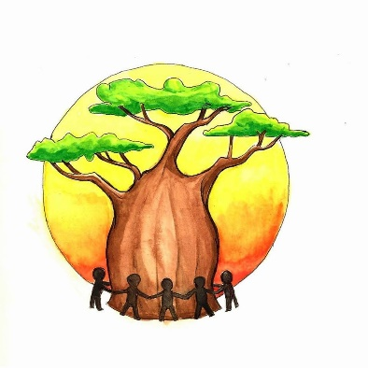
FUTURE FOUNDATIONS
NEWSLETTER MARCH 2021

Welcome to our first newsletter.
What a year it has been. We hope you are all bearing up in these difficult times. Future Foundations felt that as we cannot fundraise and raise awareness face to face, doing a regular newsletter would help keep you up to date with the essential work we are doing to sponsor young people in the Kilifi / Sabaki district of Kenya to obtain a secondary and / or further education qualification.
Best wishes,
Sharon and Joseph Lewa
History Joseph grew up in Sabaki, Kenya, and was the first person from his village to go to university. This was due to his uncle sponsoring him to go to secondary school. Joseph had to work at nights, weekends and holidays to get pocket money and also paid some of the school fees as well as to provide for his six younger siblings and mum, as his dad passed away in 2002, when he was 16 years old. In 2010, Vicki & Sam Samuels and Sharon (his now wife) visited Rainbow Community Care Orphanage, where Joseph was working. Vicki & Sam decided to sponsor him to go to Mount Kenya University. In 2012, Joseph graduated with a Diploma in Social Work & Community Development. Joseph now lives in the Isle of Skye with his wife, Sharon, who he met at Rainbow, and their two daughters Anna & Faith. He works as a Programme Assistant at Columba 1400, a project which supports young people from disadvantaged backgrounds. Sharon is originally from Skye and works as a social worker for NHS Highland. Joseph knows that without the support and faith of his uncle, Vicki & Sam, that his life (and his siblings’ lives) would be very different. Future Foundations was started in April 2013 to support young people in Joseph’s hometown in Sabaki, Kenya.

What We Do
Future Foundations main objectives are to facilitate access to higher and further education for young people aged 12-25 years, from disadvantaged families who are unable to pay for education fees and additional costs, to improve future careers / prospects. To date we have supported 14 young people.
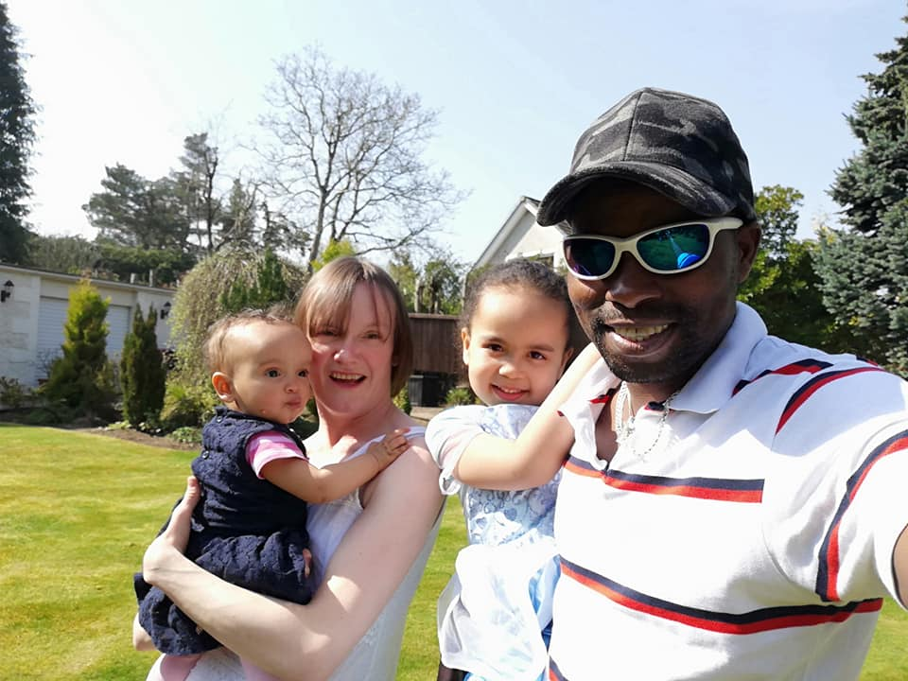
+
Website https://www.futurefoundations.info
www.facebook.com/futurefoundationskenya

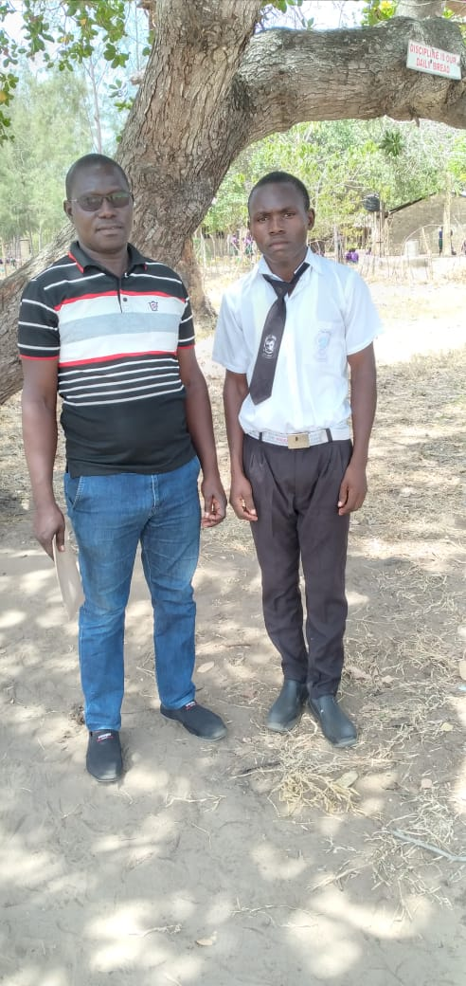
OUR LATEST SPONSORSHIP
Silvano is our newest young person to be sponsored by Future Foundations. Silvano is from Mjanaheri at Magarini /Malindi district in Kilifi county of Kenya, and his mum, Salama, had managed to pay for the first term of his first year at secondary school, however she could not pay the remainder of the fees. Salama is a single mother of six children who never went to school herself. Despite this, she has made a small business for herself by making and selling items on the beaches to tourists and she has taught herself English and Italian. Although Salama has been able to make a living for herself, she told us that she does not want her children to struggle as she has, and she strongly believes education is essential! Future Foundations has helped Silvano get into a local secondary school which will mean any travel costs to go to school will be little as often it is these extra costs that make education impossible. We are sure Silvano (pictured below with Chiro, our trustee in Kenya) will have the same determination as his mum and that there’s exciting things ahead for him. Thanks to our supporters for making this possible!
Donating
Future Foundations entirely depends on fundraising and donations, and every penny goes towards supporting young people into education. We would appreciate it if you would consider making a donation via these methods:
Nochex
https://secure.nochex.com/charity/details.aspx?cN=Future_foundations
(we appreciate that Nochex is not as well-known as other giving sites but as there are no monthly fees and very low commission, so it means more donations go directly to sponsoring young people)
Easyfundraising
https://www.easyfundraising.org.uk/causes/futurefoundations/
AmazonSmile
https://smile.amazon.co.uk/ch/SC045090
CONTACT US
We are always delighted to receive comments, ideas and any offers of support with all aspects of the charity so place get in touch via Facebook, Instagram or email futurefoundations@outlook.com
Trustee story
Our trustees are so important to us as they give up their time and effort voluntarily to ensure Future Foundations is supporting as many young people as it can. Here is Julia’s story on why she is one of our amazing trustees:
Julia Rudram is an Occupational Therapist for NHS Highland. She was born in Zambia, and grew up in Botswana until she was 14. Julia travelled a lot around Southern Africa but doesn’t remember making it as far north as Kenya. Julia told us that it will be great to join the team and get behind the young people in Kenya.

